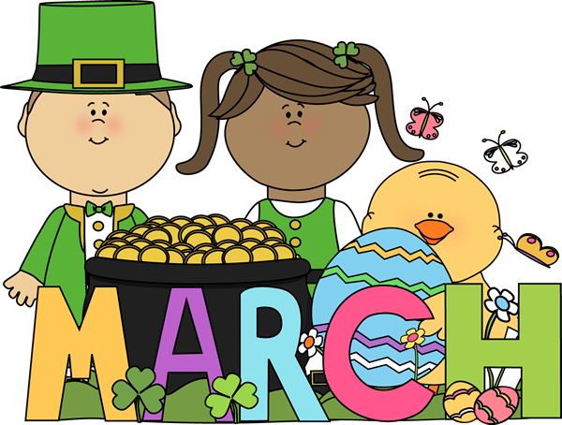
Sunday | Monday | Tuesday | Wednesday | Thursday | Friday | Saturday
1 | 2  Chicken Tenders  French Fries  Kernel Corn  Fruit Snack  Juice Box | 3  Turkey Meatballs  Yellow Rice  Green Beans  Apple Slices  Juice Box | 4  Pizza  Fresh Salad  Cookie  Juice Box | 5  Snow Day | 6  Snow Day | 7
8 | 9  Jr. Hoagie  Chips  Pudding  Juice Box | 10  Baked Chicken  Roasted Potatoes  Mixed Veggie  Apple Sauce  Juice Box | 11  Corn Dog  Baked Beans  Chips  Juice Box | 12  Spaghetti  Fresh Salad  Garlic Bread  Cookie  Juice Box | 13  Pizza  Fresh Salad  Fruit Snack  Juice Box | 14
15 | 16  Chicken Patty  French Fries  Vegetable Medley  Cookie  Juice Box | 17  Hot Dog  Baked Beans  Chips  Juice Box | 18  Turkey Taco  Yellow Rice  Lettuce/Cheese  Fruit Roll Up  Juice Box | 19  Fried Chicken  Mac and Cheese  Green Beans  Apple Sauce  Juice Box | 20  Jr. Hoagie  Chips  Jell-0  Juice Box | 21
22 | 23  Fish  Potato Wedge  Vegetable Medley  Pudding  Juice Box | 24  Spaghetti  Fresh Salad  Garlic Bread  Fruit Snack  Juice Box | 25  Chicken Tenders  French Fries  Green Beans  Cookie  Juice Box | 26  Hot Dog  Baked Bans  Chips  Juice Box | 27  Pizza  Fresh Salad  Cupcake  Juice Box | 28
29 | 30  Sloppy Joe  Tatar Tots  Kernel Corn  Fruit Cup  Juice Box | 31  Corn Dog  Baked Beans  Chips  Juice Box

~revised 3/9/15

